Name_____________________________________ Age_____________ DoB ___________________(D/M/YY)
Address________________________________________________________________________________________
_________________________________________________________________________________________________
Mobile Phone___________________________________ Other________________________________________ Phone______________________________________E-mail_____________________________________________
Emergency contact and number______________________________________________________________
GP: ____________________________________________________________________________________________
Occupation______________________________________Height___________________Weight____________
Gender_________________________ Relationship status ____________________________
Children & ages __________________________________________________________________________________________________________________________________________________________________________________________________
Menstrual cycle? (If Female) _________________________________________________________________________________________________

The following information will be used by your therapist to plan safe and effective sessions. Please answer the questions to the best of your knowledge and as you feel comfortable.

Reason for seeking treatment/ what is happening in your life/ date of onset?
_________________________________________________________________________________________________
_________________________________________________________________________________________________
What do you hope to achieve from treatment, today and long term?
_________________________________________________________________________________________________
_________________________________________________________________________________________________
Previous and current therapy. Reason and duration.
_________________________________________________________________________________________________
_________________________________________________________________________________________________
What did you like/dislike about it? _________________________________________________________________________________________________
_________________________________________________________________________________________________

Do you have any present medical issues?
__________________________________________________________________________________________________________________________________________________________________________________________________

Are you taking any medication/supplements?
__________________________________________________________________________________________________________________________________________________________________________________________________
Eating habits___________________________________________________________________________________
Sleeping Habits________________________________________________________________________________
Exercise rountine_______________________________________________________________________________
Are you pregnant? (If Female) If so how many months? ______________________________________
Daily Intake: Water ____________ Caffeine __________ Alcohol ___________ Tobacco _____________
Do you take recreational drugs and if so, what? _________________________________________________________________________________________________
Please list any surgeries or hospitalisations that you have had or know you will have:
_________________________________________________________________________________________________
_________________________________________________________________________________________________
_________________________________________________________________________________________________
Please list any injuries you have or had (include minor aches and pains or areas for attention): ___________________________________________________________________________________________________________________________________________________________________________________________________________________________________________________________________________________________________
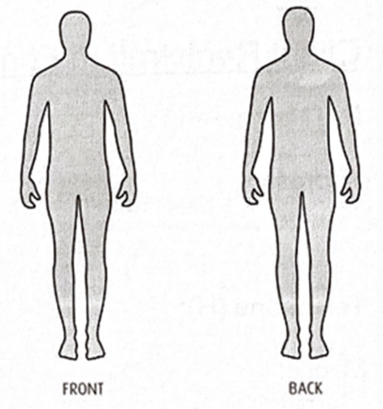

Please list any traumatic or major life threatening events that occurred in your life and what happened?
__________________________________________________________________________________________________________________________________________________________________________________________________

Please mark any of the following that may apply to you with a 'C” for current 'P' for past or 'CH' for chronic
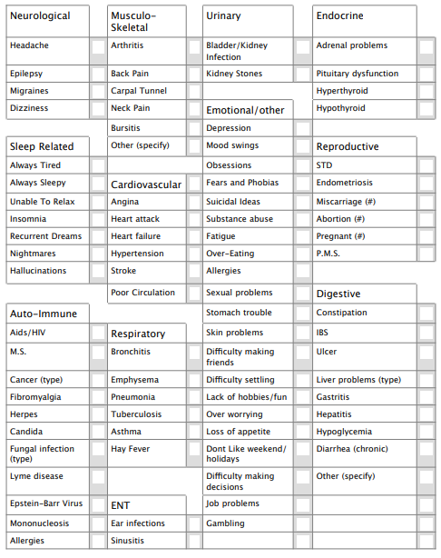

What makes you happy? What do you enjoy doing? (Resources and Hobbies)
____________________________________________________________________________________________________________________________________________________________________________________________________________________________________________________________________________________________________________________________________________________________________________________________________
Is there anything else you want to share or want me to know?
____________________________________________________________________________________________________________________________________________________________________________________________________________________________________________________________________________________________________________________________________________________________________________________________________

Appointments & Cancellations

I ask you to cancel at least 48 hours in advance so that I can give this time slot to those who need it. As long as I receive your cancellation at least 24 hours before the appointment, I will not charge you for the missed meeting and will always try to reschedule within the same week. If you cancel within 24 hours of the appointment time, I will ask for full payment.

Payment

By booking an appointment I agree to the financial commitment. The rate of treatments are available on Louise’s website. Rates will be confirmed upon booking and will be due at the first appointment. Payments can be made by advance bank transfer or by cash or card at the appointment.
Offers must be paid in full at the first appointment and are valid for 6 months from that date.
Some discounted rates may be available. These will be arranged and confirmed prior booking and paid for at the first appointment.

Covid

I confirm, to the best of my knowledge, I am free of the symptoms of Covid-19 and have not recently been in contact with anyone who has.

I agree, in the event that I develop symptoms of Covid-19 in the following 5 days after attending this practice, to inform the therapist of my changed status.

Code of Conduct, Ethics and Performance

Maisie is a registered member of ICrA (International Cranial Association) and CHNC (Complementary & Natural Healthcare Council) and BCMA (British Complementary
Medicine Association) and works in line with all of their codes of conduct, ethics and performance.

Personal Agreements

I acknowledge that my therapist is not a doctor and does not diagnose illness, disease or any other physical or mental disorder. I understand that Energy Therapists are not primary healthcare providers, and that Energy Therapy not a substitute for medical examination. I acknowledge that there is no assurance or guarantee to me as to the results of a therapy treatment or series of treatments. I acknowledge that with any treatment there can be risks and those have been explained to me in full and I assume those risks.

I acknowledge and understand that my therapist must be fully aware of my existing medical and life conditions. I have disclosed to my therapist all medical and life conditions affecting me. I acknowledge it is in my best interests and responsibility to keep my therapist updated on my medical history and any life conditions that may affect my treatment. The information

I have provided is true and complete to the best of my knowledge.

I have read and understood the above and am receiving treatment at my own request.

In accordance with GDPR (General Data Protection Regulation), I understand that my information be held in paper copy and kept locked in Maisie’s home office and not held at the Centre for Health

They are held for at least seven years following the final treatment (for children – until they are 21 + 7 years) and are then destroyed.

Signed______________________________________________________ date: _____________________________
If on behalf of a minor: Signed on behalf of___________________________________________________
ALL 6 PAGES ARE STRICTLY PRIVATE AND CONFIDENTIAL

MAISIE’S INFINITE ENERGY HEALING LTD
28 LYNDHURST DRIVE SEVENOAKS, TN13 2HQ
07583451319
maisies@maisieshealing.com
www.maisieshealing.com

